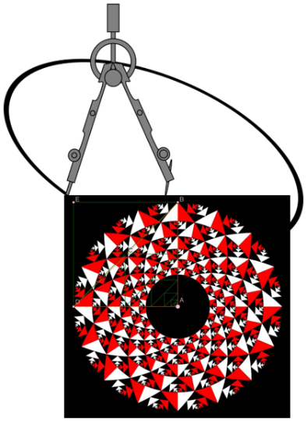
SBIDZ Teacher Professional Development Course
Module 2: Meetkunde-onderrig met tegnologie
Engelse vertaling sal op versoek verskaf word.
Maak seker jy werk op ‘n hoë vlak van interpretasie en ontleding. Die vrae is slegs om jou te oriënteer, die diepte waarmee jy ondersoek en dink sal jou taak van ander onderskei.
Stoor jou voltooide taak elektronies met WEEK 8 in die naam van die dokument. Jou weeklikse take is deel van jou portfolio van individuele werk en maak 10% van die punte op.

Week 8: Terugskouende taak.
- Gebruik GSP om ‘n tessellasie van vervormbare (algemene) driehoeke te konstrueer. Die tessellasie moet gebruik kan word om ten minste drie eenhede te bied om oppervlakte mee te “meet: die oorsronklike driehoek, ‘n driehoek gelykvormig aan die oorspronklike, maar een ordegrootte groter; en ‘n vierhoek wat op die oorspronklike driehoek gebaseer is.
  - Gebruik die “construct … interior” tool om die binnestreke van die driehoeke te skep, en van die vierhoek(e), sodat jy hulle oppervlaktes kan meet.
  - Gebruik die “calculate” tool onder die number tools om die ratios te bereken van die oppervlaktes van die oorspronklike driehoek en die gelykvormige vergrote driehoek, asook dieoorspronklike driehoek en die vierhoek.
- Begin met ‘n algemene driehoek in GSP. Maak die nodige konstruksies om te dinamies te redeneer dat die oppervlakte van enige driehoek gelyk is aan die helfte van die oppervlakte van ‘n reghoek waarvan …
- Begin met ‘n algemene parallelogram in GSP. Maak die nodige konstruksies om die formule van die oppervlakte van ‘n parallelogram te vergelyk met die van ‘n reghoek.
- Begin met ‘n algemene vlieër in GSP. Maak die nodige konstruksies om die formule van die oppervlakte van ‘n vlieër af te lei.
- Begin met ‘n algemene trapezium in GSP. Maak die nodige konstruksies om die formule van die oppervlakte van ‘n trapezium af te lei.
Maak deurgaans gebruik van transformasie.

Pythagoras hersien:
Bron: http://jwilson.coe.uga.edu/EMT668/EMT668.Student.Folders/HeadAngela/essay1/Pythagorean.html
Die volgende bewys van Pythagoras se telling is direk gebaseer op gelykvormigheid (onthou alle reghoekige driehoek is gelykvormig, en all vierkante is gelykvormig), en is ‘n goeie manier om Pythagoras te stelling EN gelykvormigheid te hersien.

Bhaskara's Second Proof of the Pythagorean Theorem
In this proof, Bhaskara began with a right triangle and then he drew an altitude on the hypotenuse. From here, he used the properties of similarity to prove the theorem.
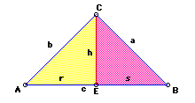
Now prove that triangles ABC and CBE are similar.
It follows from the AA postulate that triangle ABC is similar to triangle CBE, since angle B is congruent to angle B and angle C is congruent to angle E. Thus, since internal ratios are equal s/a=a/c.
Multiplying both sides by ac we get
sc=a^2.
Now show that triangles ABC and ACE are similar.
As before, it follows from the AA postulate that these two triangles are similar. Angle A is congruent to angle A and angle C is congruent to angle E. Thus, r/b=b/c. Multiplying both sides by bc we get
rc=b^2.
Now when we add the two results we get
sc + rc = a^2 + b^2.
c(s+r) = a^2 + b^2
c^2 = a^2 + b^2,
concluding the proof of the Pythagorean Theorem.

Hierdie bewys van Pythagoras se stelling is gebaseer op vouwerk (refleksie) en op die oppervlakte van ‘n trapezium. Weereens, ‘n goeie manier om Pythagoras se stelling te hersien en die oppervlakte van trapeziums.

Visualisering en denke:
Wat was die vorm van die papier voordat dit gevou is soos in die figuur?
Garfield's Proof
The twentieth president of the United States gave the following proof to the Pythagorean Theorem. He discovered this proof five years before he become President. He hit upon this proof in 1876 during a mathematics discussion with some of the members of Congress. It was later published in the New England Journal of Education.. The proof depends on calculating the area of a right trapezoid two different ways. The first way is by using the area formula of a trapezoid and the second is by summing up the areas of the three right triangles that can be constructed in the trapezoid. He used the following trapezoid in developing his proof.
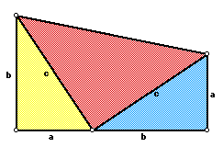
First, we need to find the area of the trapezoid by using the area formula of the trapezoid.
A=(1/2)h(b1+b2) area of a trapezoid
In the above diagram, h=a+b, b1=a, and b2=b.
A=(1/2)(a+b)(a+b)
=(1/2)(a^2+2ab+b^2).
Now, let's find the area of the trapezoid by summing the area of the three right triangles.
The area of the yellow triangle is
A=1/2(ba).
The area of the red triangle is
A=1/2(c^2).
The area of the blue triangle is
A= 1/2(ab).
The sum of the area of the triangles is
1/2(ba) + 1/2(c^2) + 1/2(ab) = 1/2(ba + c^2 + ab) = 1/2(2ab + c^2).
Since, this area is equal to the area of the trapezoid we have the following relation:
(1/2)(a^2 + 2ab + b^2) = (1/2)(2ab + c^2).
Multiplying both sides by 2 and subtracting 2ab from both sides we get
concluding the proof.
Natuurlik is daar nou ‘n vraag: MOET die begin vorm wees wat dit hier is? Hoekom?
En daaruit volg…

